Step 1: Download everything and place it into a folder (preferably on your desktop)

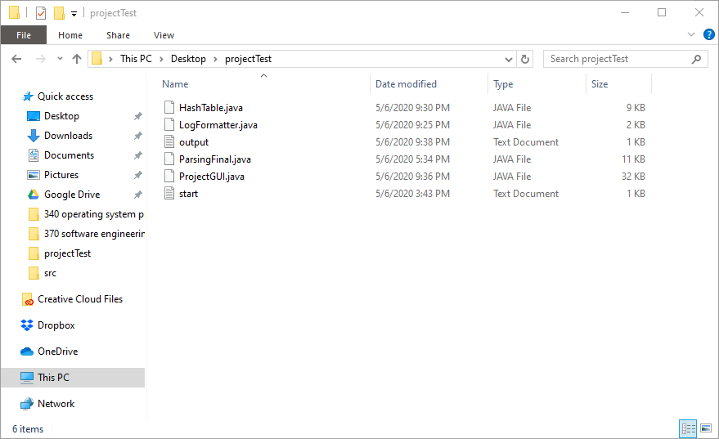

Step 2: open your cmd and follow the instruction

Type: cd [“path of folder containing files above”]

E.g cd “C:\Users\marin\Desktop\projectTest”

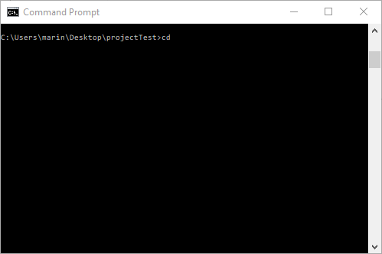

Step 3:

Type javac \*.java

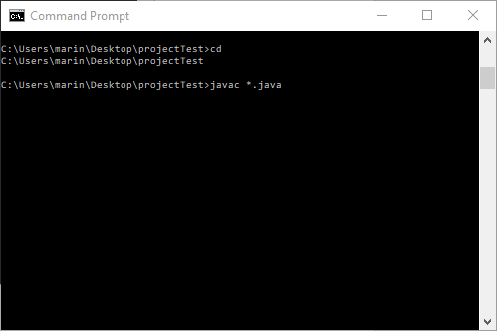

This is how your folder with the files should look like

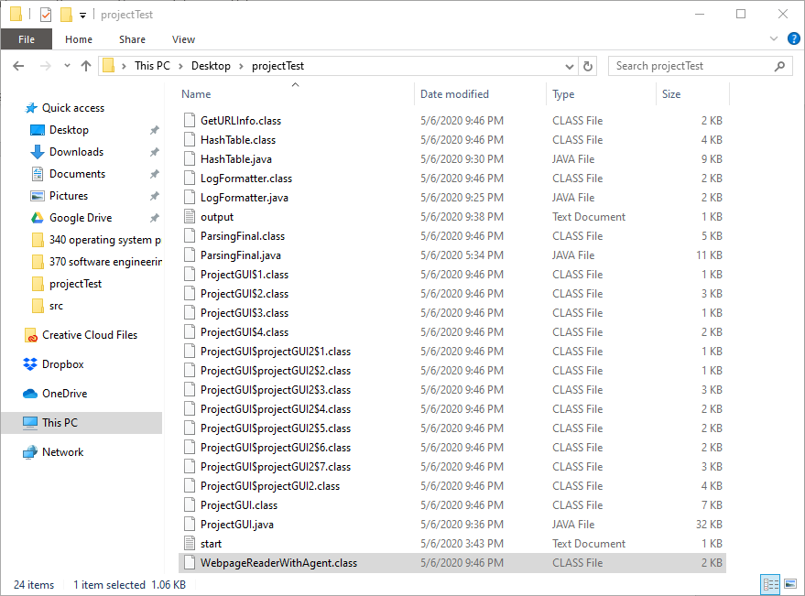

Step 4: type java projectGUI -d [“path to folder containing java files”] -o [output file]

E.g. “java ProjectGUI -d "C:\Users\marin\Desktop\projectTest" -o output.txt”

If successful you console should look like this:

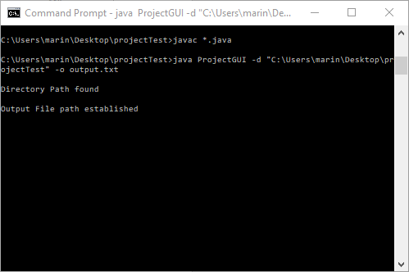

And a GUI should appear:

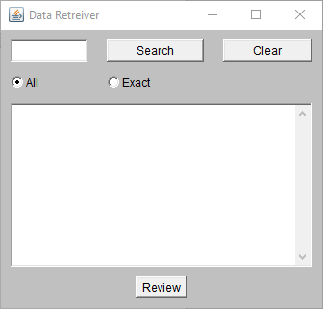

Step 5: enter your desired keyword to search on the website, and press the search button

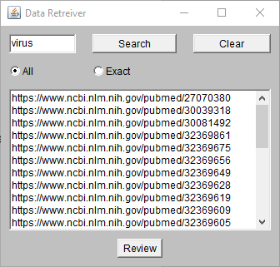

In the text area, it will show the result of papers related to the topic

And in the console, you will see the transition log from the execution

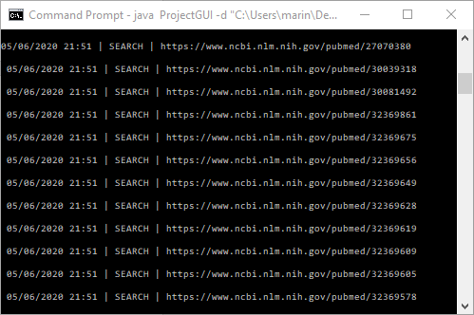

Step 6: you can now press the review button to open the second GUI

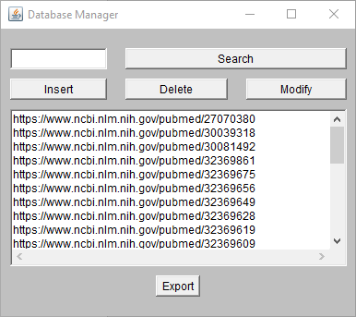

Here you can Insert/delete/search for more elements (modify doesn’t work)

Step 7: Pressing export will now export all the data to the output file we entered originally and create HTML files based on the data the links found in the Text Area of the GUI

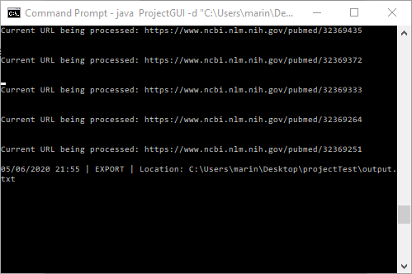

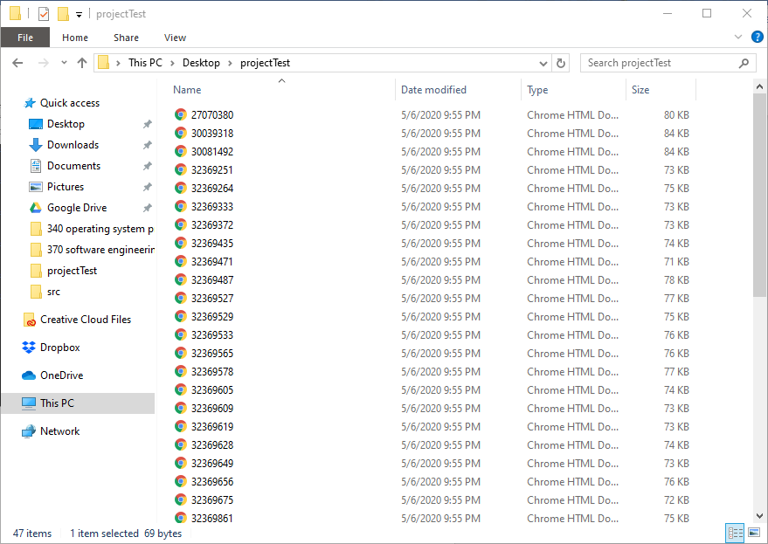

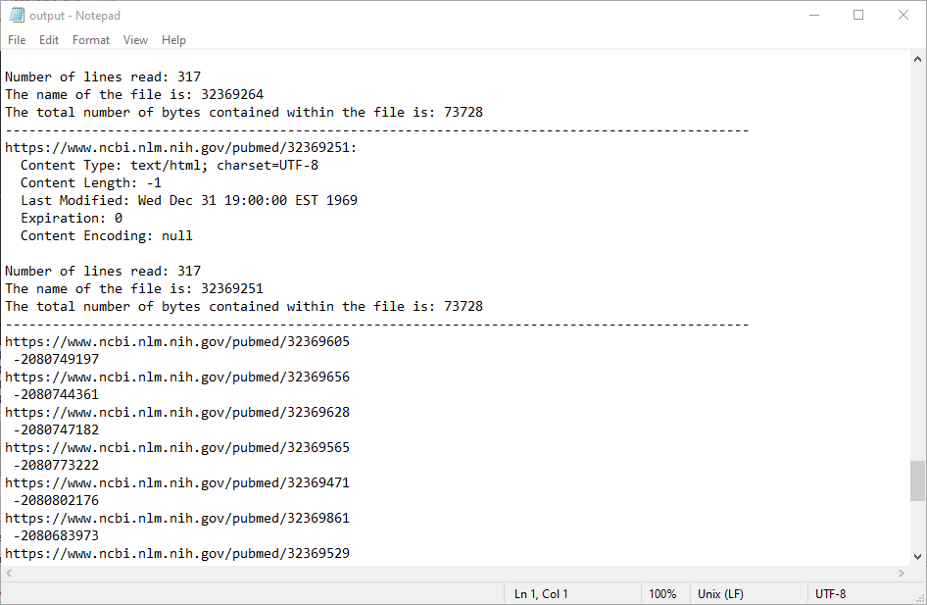

It only outputs the data stored in the Hash-table and URL info